Homework-session 2

1. What is Boolean? Write down 3 different expression that results a Boolean type (i.e. 5 == 6)

- A *Boolean* value is either true or false.

- Ex: >>> 2 == 1+1, true

>>> 2 = 3-1, false

>>> a = “”dep trai””

>>> “ha” + a == “”ha dep trai””, true

2. What is a flow chart? Draw flow chart for the following code snippet: (you can draw on a paper, take a picture of it)

- It is a type of diagram that represents the flow of execution of the program

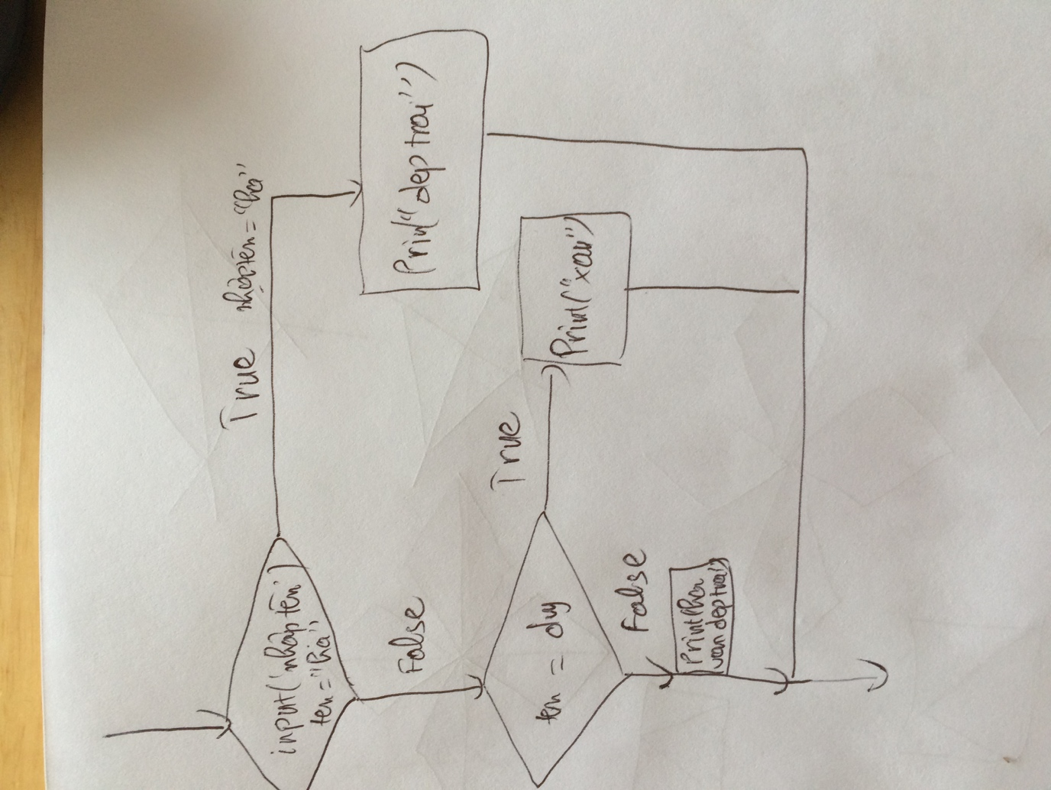

3. What is nested conditionals? Write a piece of code that uses nested conditionals

- Nested conditions comprise condition statements contained within the definition of other condition statements.

Ex:

If thoitiet == “nang”:

Print (“o nha”)

Else:

If thoitiet ==”mua”:

Print(“cung van o nha”)

Else:

Print(“ra ngoai”)